# **EMPLOYEE ATTRITION PROJECT REPORT**

## INTRODUCTION :

Employee Attrition refers to the gradual reduction in workplace size due to employees leaving or turnover (voluntarily or non-voluntarily) and not being replaced immediately. Employee attrition increases the cost of recruitment, hiring and training replacement in the company. It is a critical HR metric that affects productivity, morale and productivity cost.

### Objective :-

In this project, as a data analyst different variables or factors are analyzed to determine the reason for employees’ attrition, so that effective measures can be suggested to the business or company for retention of employees. Different factors like age, gender salary hike percent, work life balance, job role and satisfaction etc. have been taken into consideration to identify the key factors influencing attrition and proper amendments and requirements for retention of employees.

The dataset used for analysis is created by the IBM data scientists for HR analytics.

### Tools Used :-

Tools used for Data Cleaning, Exploratory Data Analysis and Visualizations are as follows :–

* Excel
* Jupyter Notebook
* Python libraries (pandas, NumPy, matplotlib, seaborn and squarify)

## KEY FINDINGS:

Different trends and patterns are discovered after comparing Age, Gender, Job satisfaction, salary hike percentage, business travel frequency and years at the company etc.

1. There is a total of 1470 employees in the company and the attrition count are 237, which contributes the 16.12%, which shows that 16.12% employees have decided to leave the company during the analyzed period.

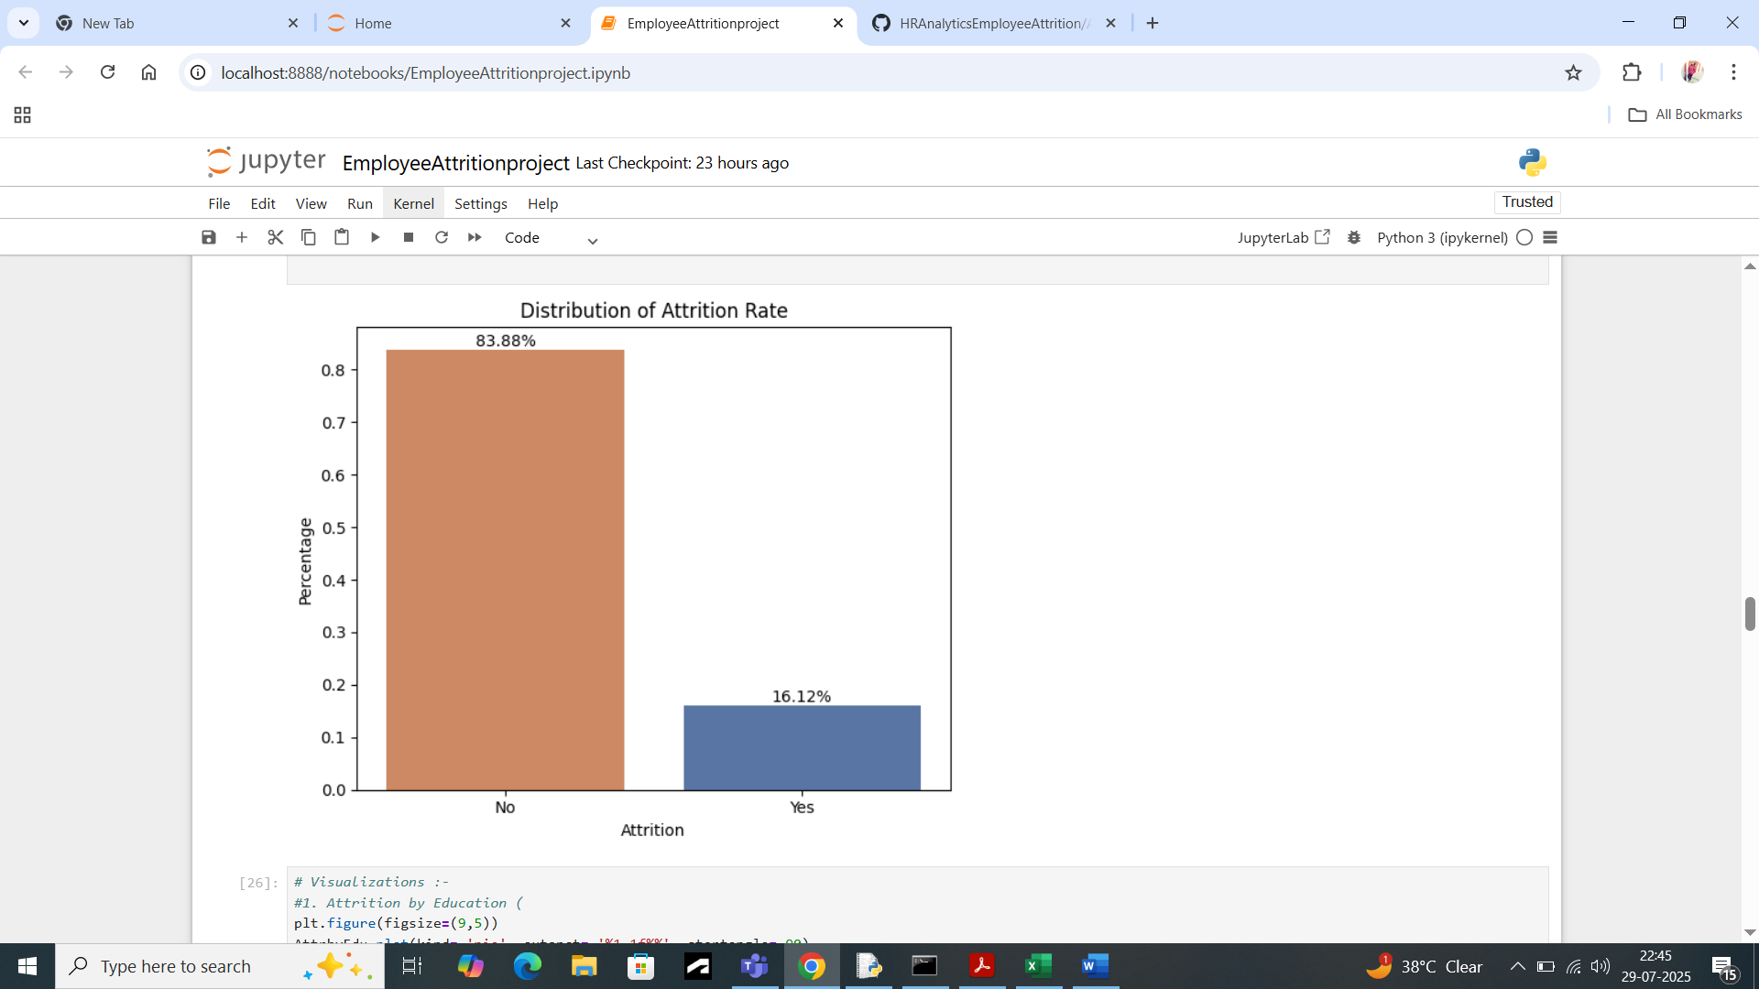

1. Average Age of the employees working in the company is 37 years. Most of the employees are in the age group of 30-40. We can say that most of the employees are in the growth age of their careers. Attrition rate is also high among this age group of people. So, Age is a great factor which is influencing the attrition. People of this age or in this phase want to grow themselves and seek the best opportunities. So, it can be considered one of the evident factors of attrition.

1. The average monthly income of the employees is 6503. The employees with low monthly income are more prone to leave the company. Employees having monthly income of less than the average income are the people who left the company during a specified period. Same thing is with daily rate. So, monthly income and daily rate also have a great influence on attrition.

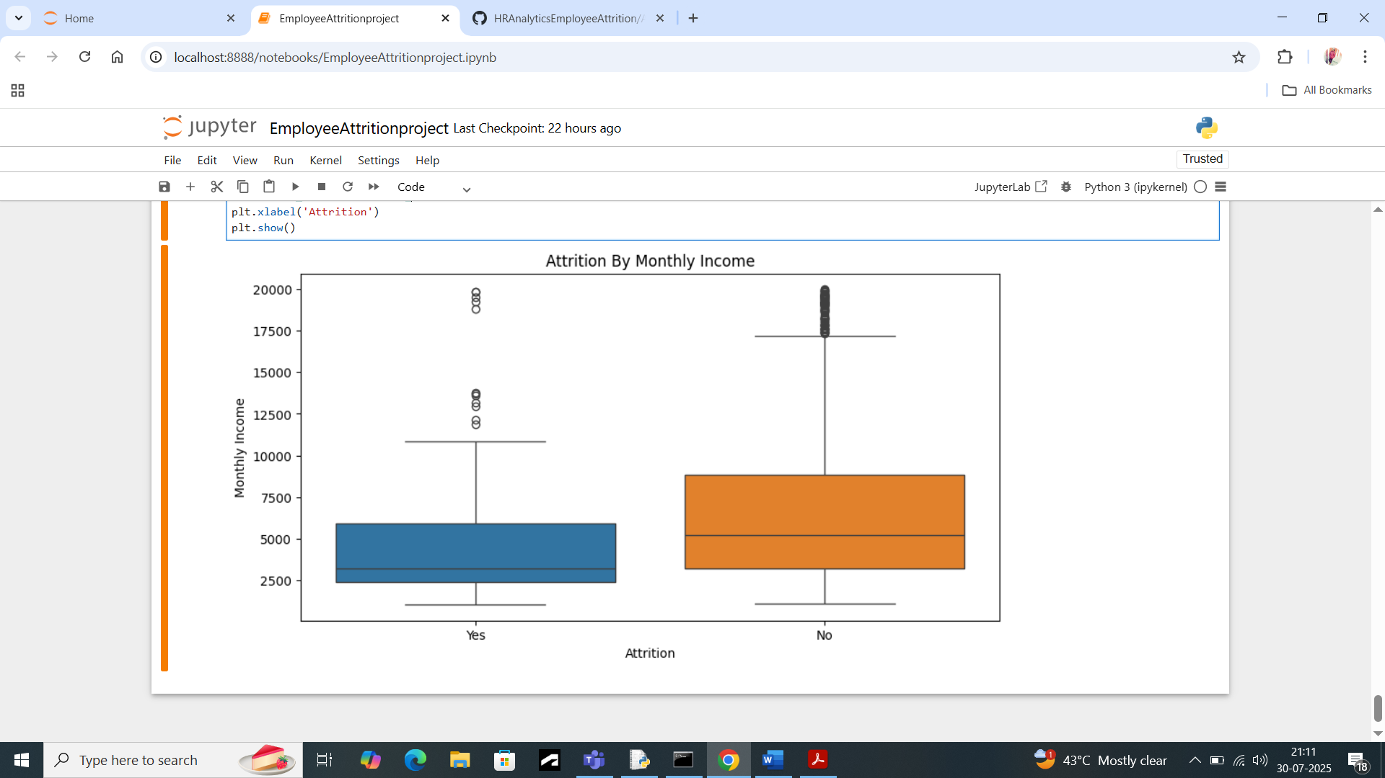

1. a) There are three departments in the company. The highest attrition is in the Research and Development department followed by the Sales department and the least is in the HR department. It shows that in the R&D department employees are facing some issues which need to be corrected for maintenance of workforce, While HR department is more stable.

b) The basic salary hike is 15% which is average salary hike percent. Employees receiving less salary hike than this average hike are leaving the company. Highest attrition is among the people who are getting 12-14% of salary hike. Percent salary hike is an another important factor for attrition.

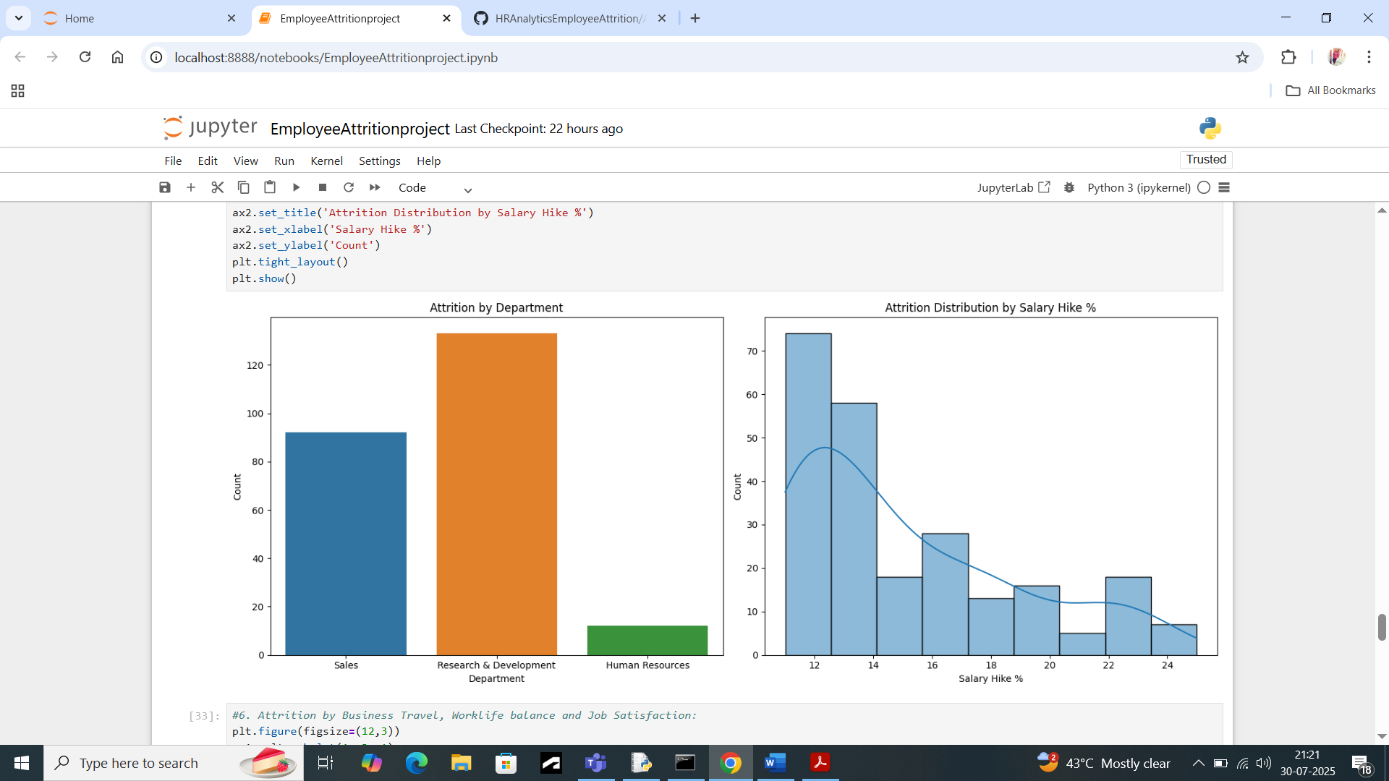

1. The average tenure of an employee in the company is 7 years. Employees having 20 or more than 20 years of experience have a very less attrition rate. People with less years of experience are more prone to leave the company, maybe in search of better opportunities irrespective of salary hike. So, working years at the company also can be considered as an important variable.

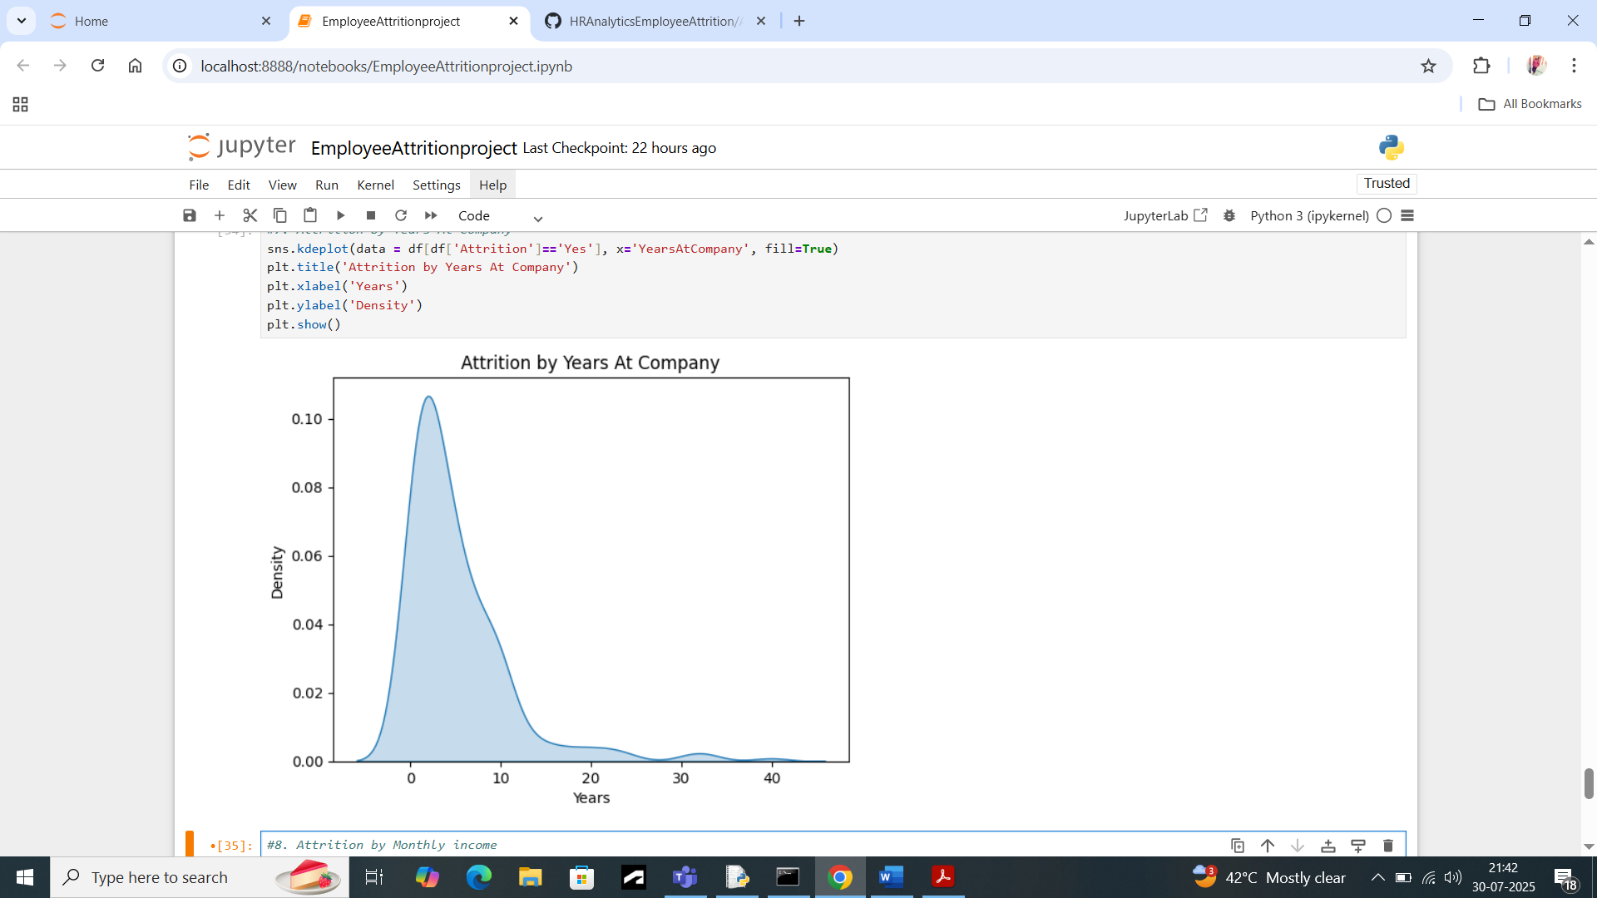

1. If we check attrition by educational background of employees and their job role most of the attrition percentage consists of **37.6%** employees with **Life Sciences** and **26.6%** with **medical** backgrounds and **Laboratory Technician** and **Research** **Scientists** followed by **Sales Executive** job roles. These educational backgrounds and job roles are correlated with attrition in the R&D department and Sales Department. **50-60** employees from the **R&D department** left the company. It is a major variable of consideration as employees are not finding better growth opportunities in this department.

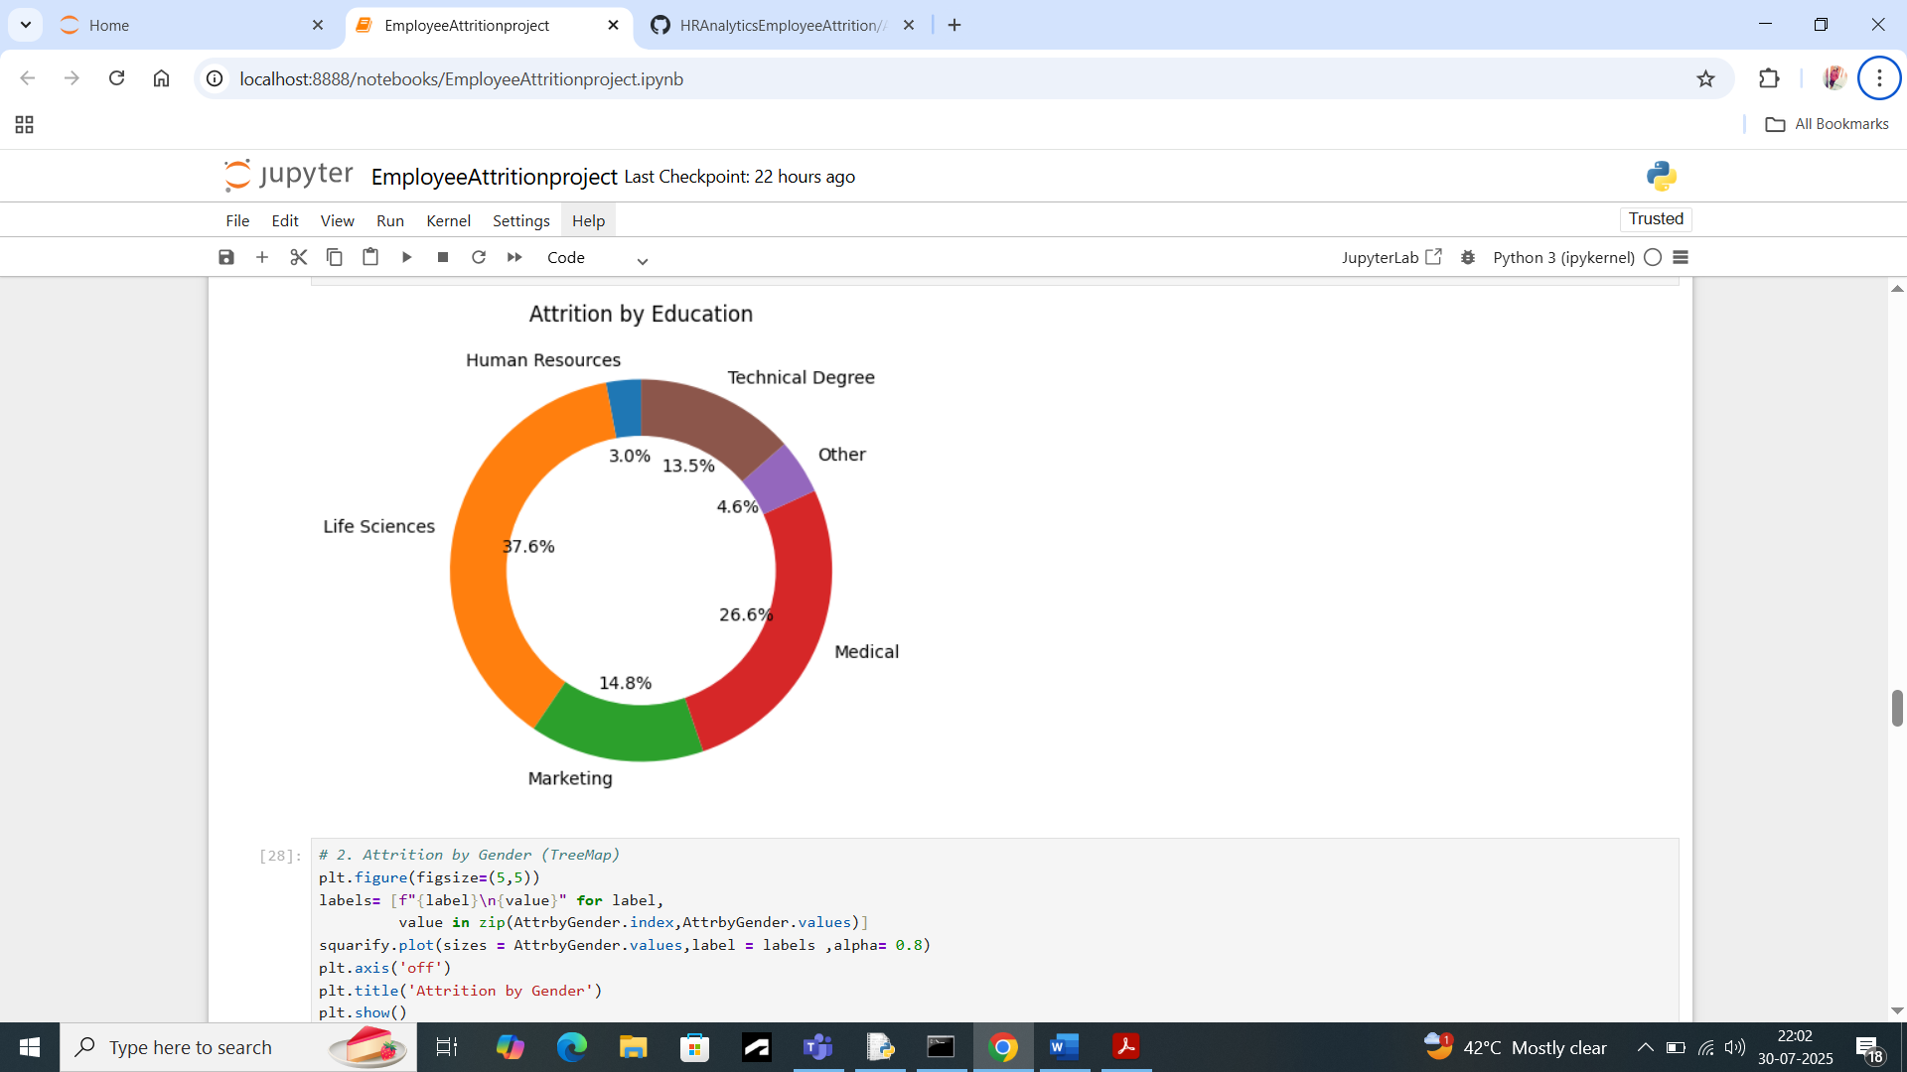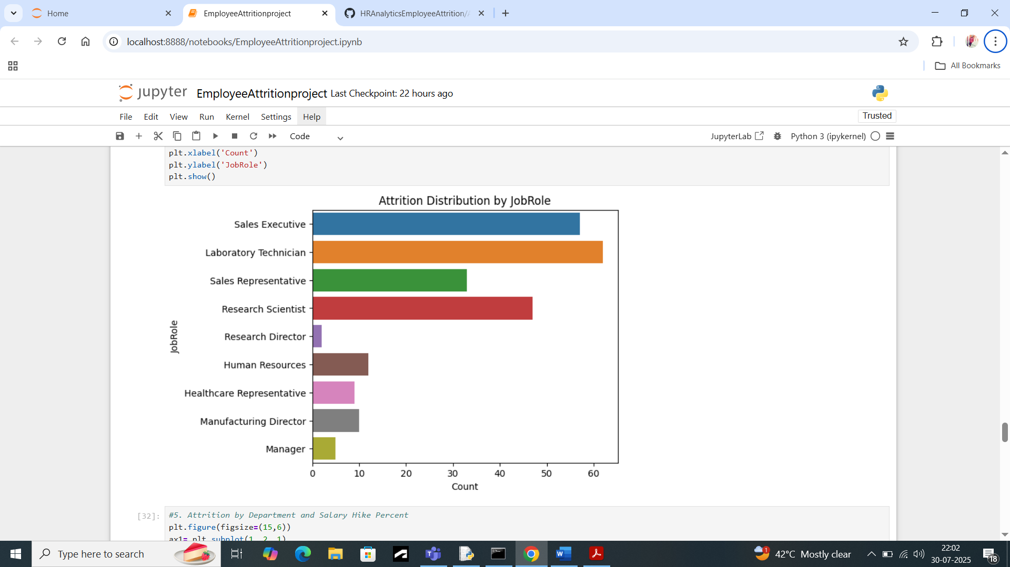

1. With all these important factors there are many factors that contribute in the attrition. Some of these factors are :-
2. Business Travel : Employees who travel rarely have the highest attrition followed by people who travel frequently, while there is very little attrition in those people who are non-travelers. If we consider attrition among people who travel frequently, then the highest number of employees left from this category.

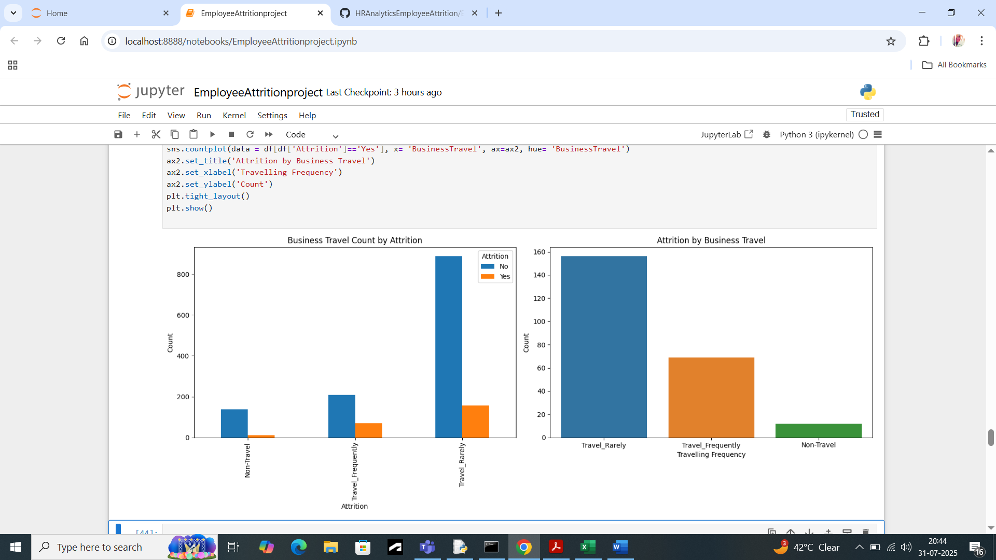

1. Work life Balance: Highest percentage of people (approx. 30%) are left from the category who rated the work life balance as Bad. Overall, the highest attrition is from the best rated work life balance category.

1. Job Satisfaction: As expected, people with low satisfaction have left the company around 20-25% of which is the highest of total attrition of all the four

categories. If we see the overall maximum number of employees have left from the medium and high satisfaction category.

1. It is also same with job involvement category in terms of the total employees who left the company out of total attrition in that category. Around 50% of employees left who had attrition and had very bad job involvement. But the highest number of attritions among employees is in the category of high job involvement.

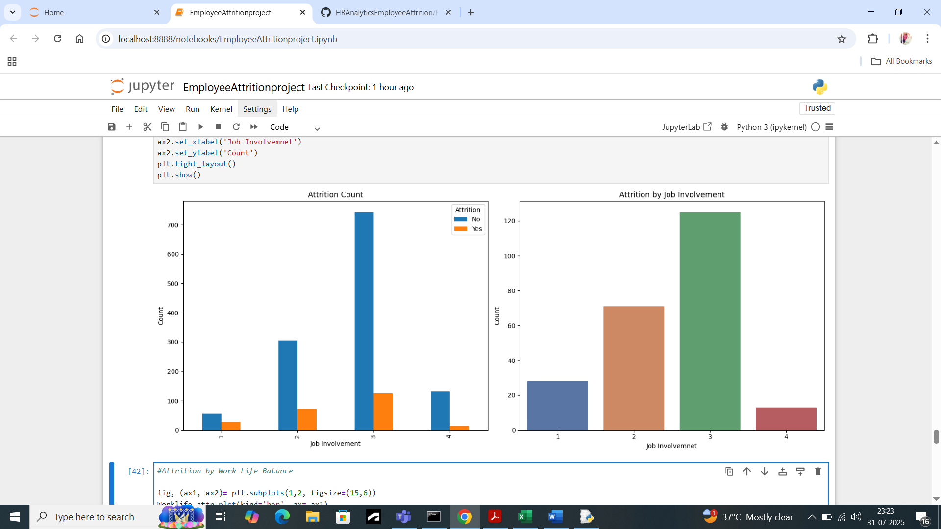

1. More than 30% of the employees who have worked overtime have left the company. So, we can say overtime has contributed to the attrition of employees.

1. On gender basis, attrition is 2% more in males than females. In performance rating, there is very less variations in attrition based on the performance rating. These both are not a strong indicator of attrition.

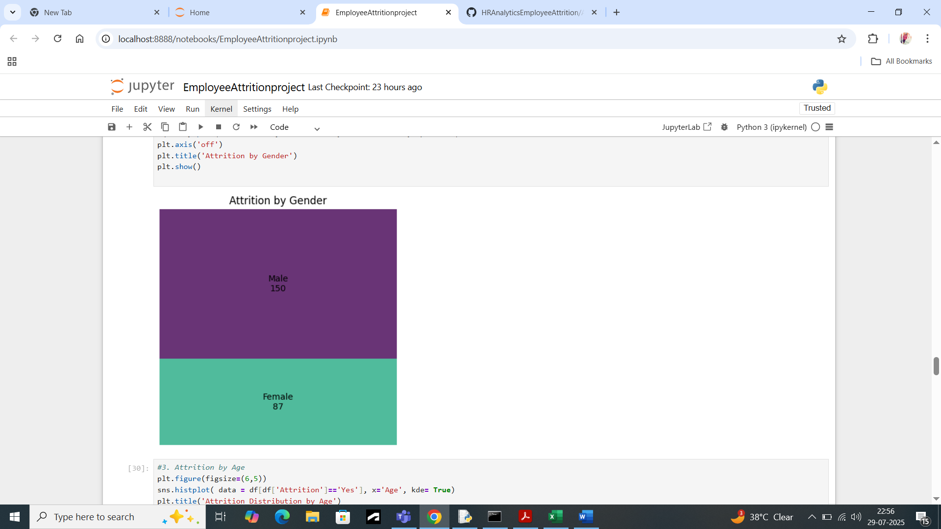

## Conclusion :-

In conclusion of this project, we can say that there are many factors that contributes to the employees’ attrition such as the Education field, Department, Education level, Overtime, Monthly income, Year at the company, job satisfaction, job involvement, business travel etc. All these factors cannot be corrected at once or completely but by making little improvements things can be better. Such as:-

1. Growth opportunities should be expanded, mostly required in the R&D department.
2. Work life balance activities should be implemented such as Work from home sometimes or no work-related issues after working hours.
3. Overtime should be accompanied by extra pay so that employees can work willingly.
4. Working conditions should be improved.
5. Salary increments should be based on performance, and a proper evaluation of the performance should be carried out.
6. Focus should be diverted on Employee engagement activities to retain employees such as issuing bonuses, travel discounts, Employee training and other extracurricular activities to refresh employees after some time.